***1) WRITE TWIKLE TWIKLE LITTLE STAR POEM USING PRINT FUNCTION AND USE A EXTERNAL MODULE***

***INPUT:***

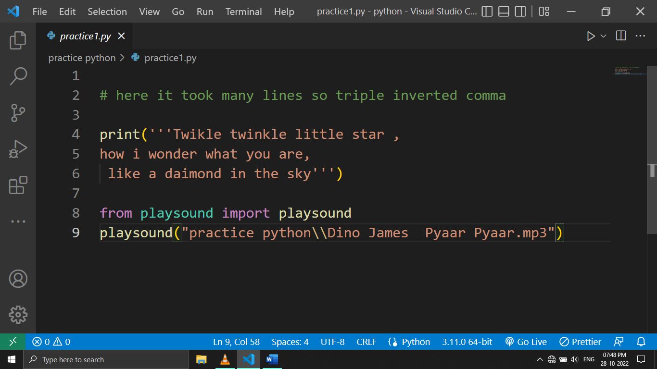

***OUTPUT:***

*Sound is playing*

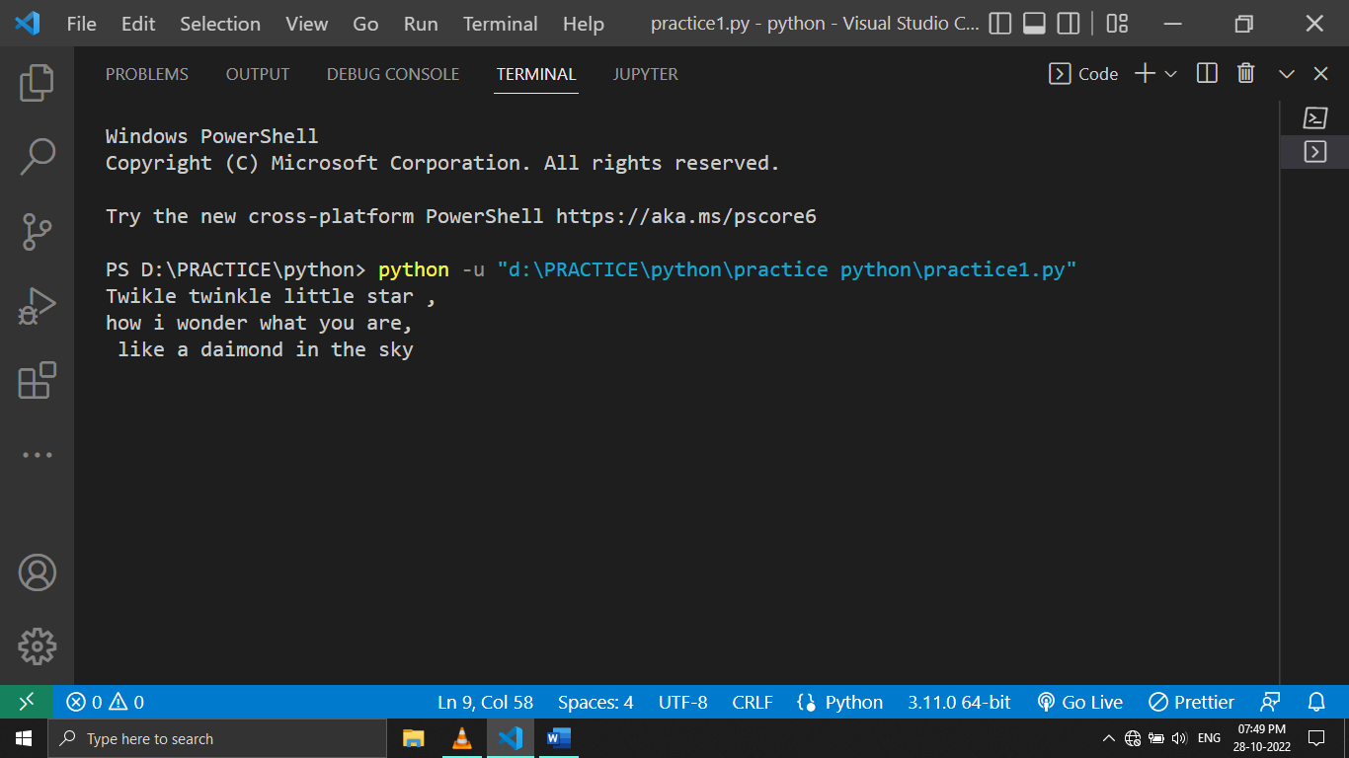

***Q2)ADDITION OF TWO NUMBERS BY USER INPUT***

***INPUT:***

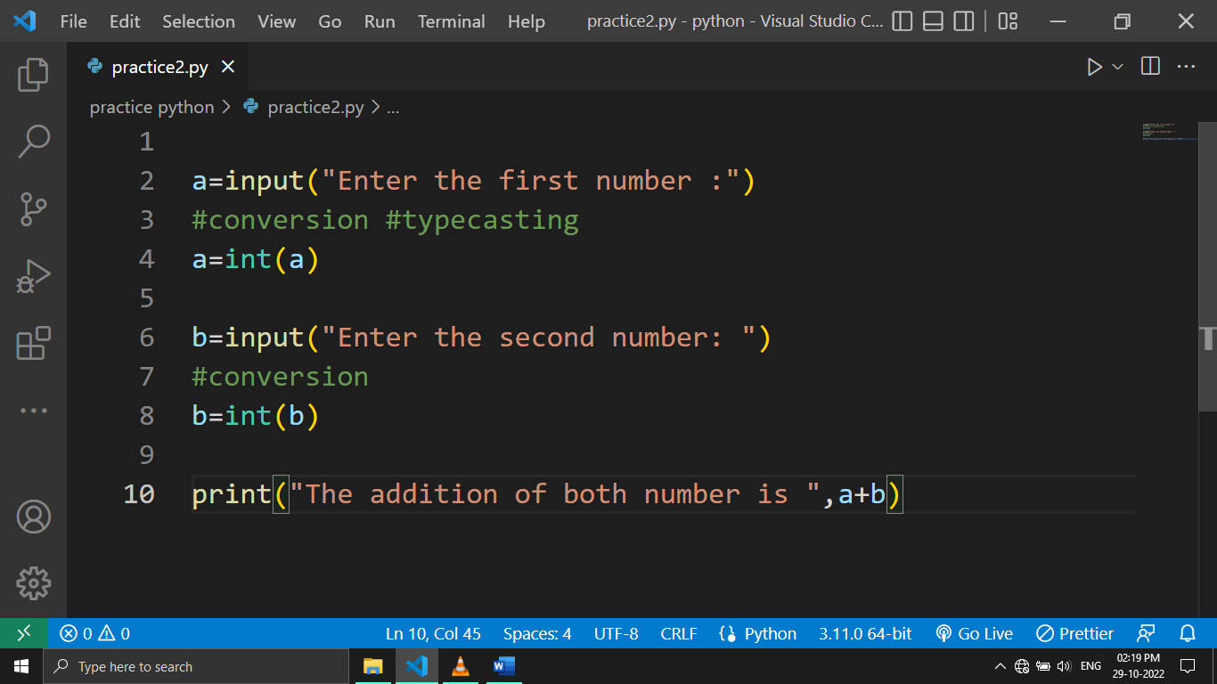

***OUTPUT:***

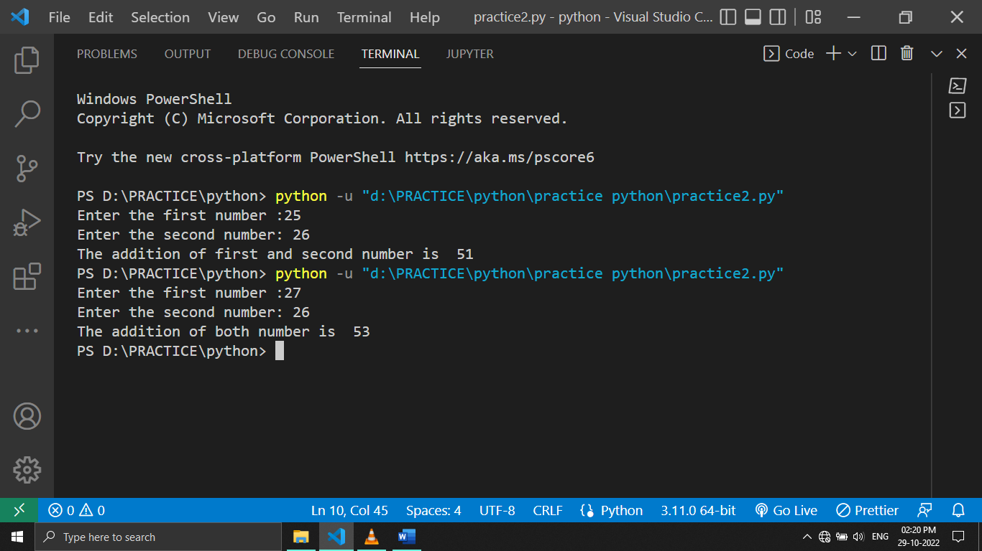

***Q3) USE COMPARISION OPERATOR TO FIND WHEATHER THE VALUE OF A IS GREATER OR NOT***

***INPUT:***

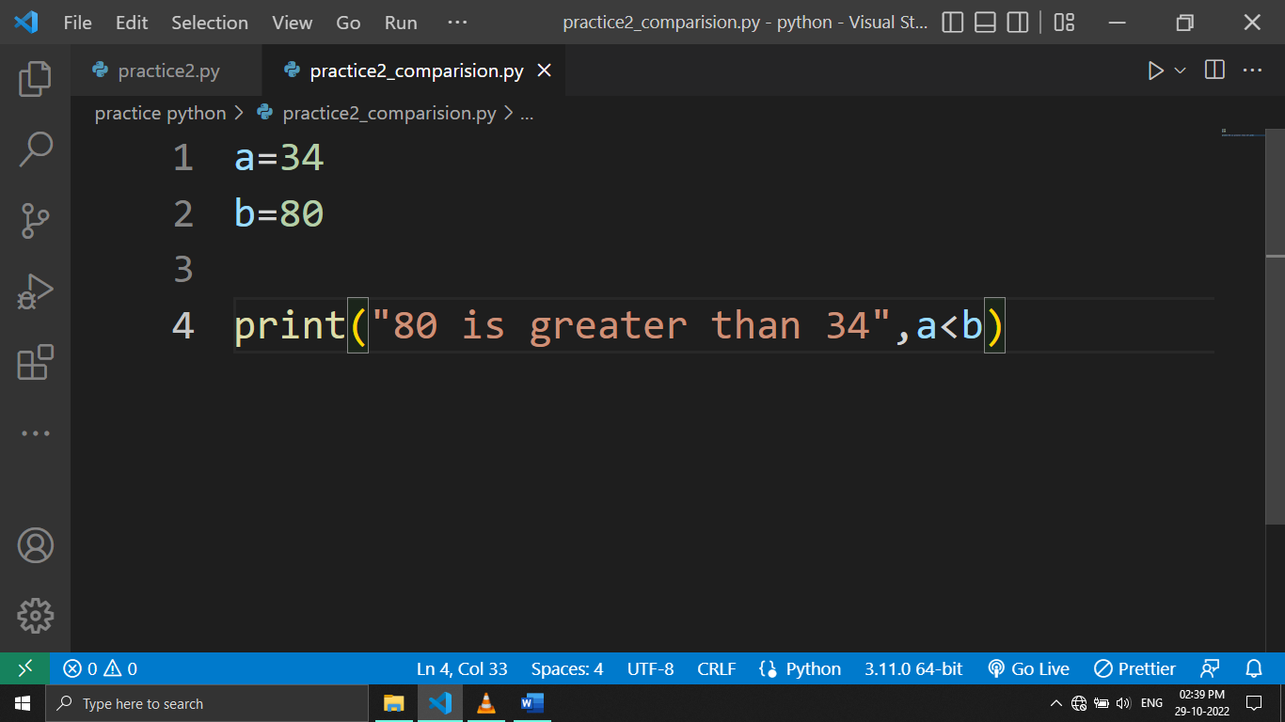

***OUTPUT:***

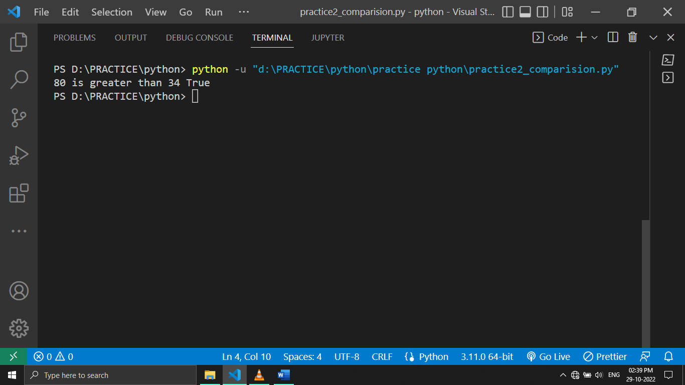

***Q4) AVERAGE OF TWO NUMBERS (FORMULA)ADD & DIVIDE BY 2***

***INPUT:***

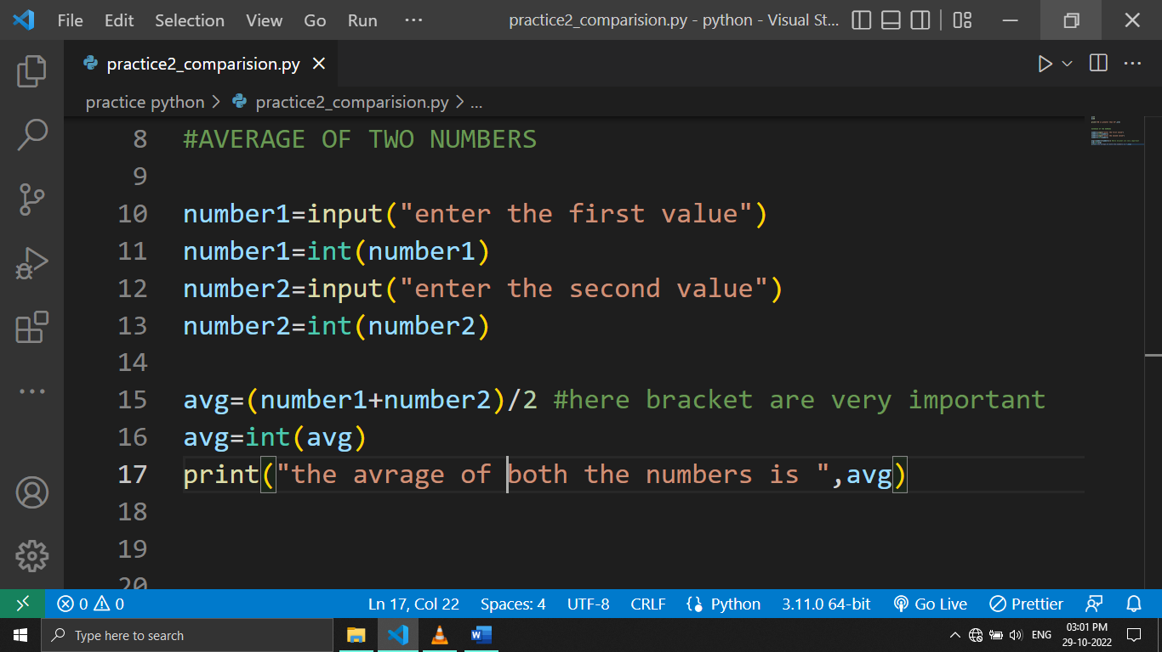

***OUTPUT:***

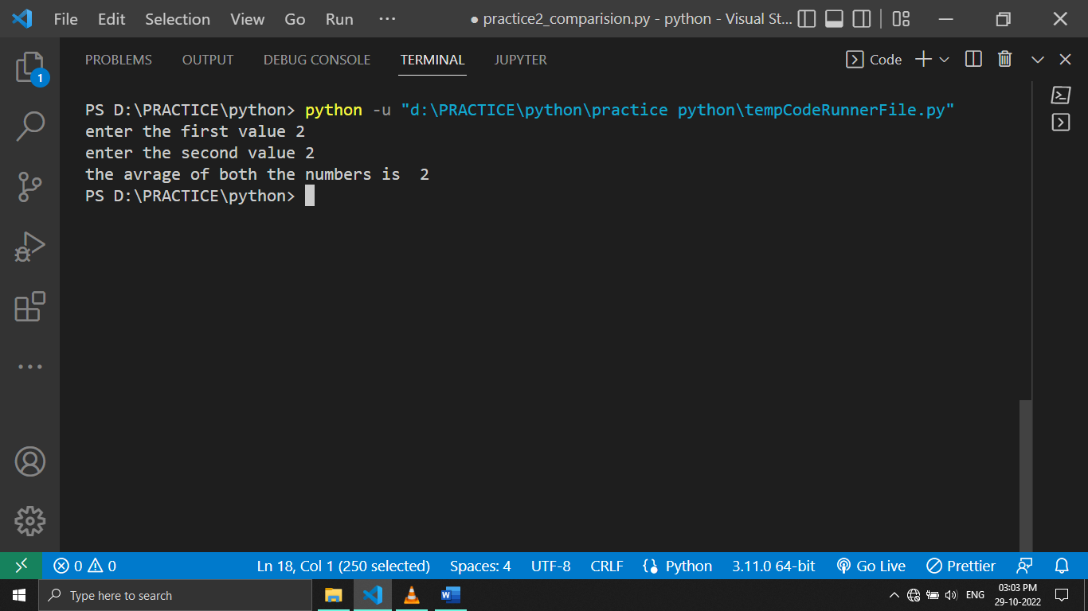

***Q5)SQUARE OF TWO NUMBERS***

***INPUT:***

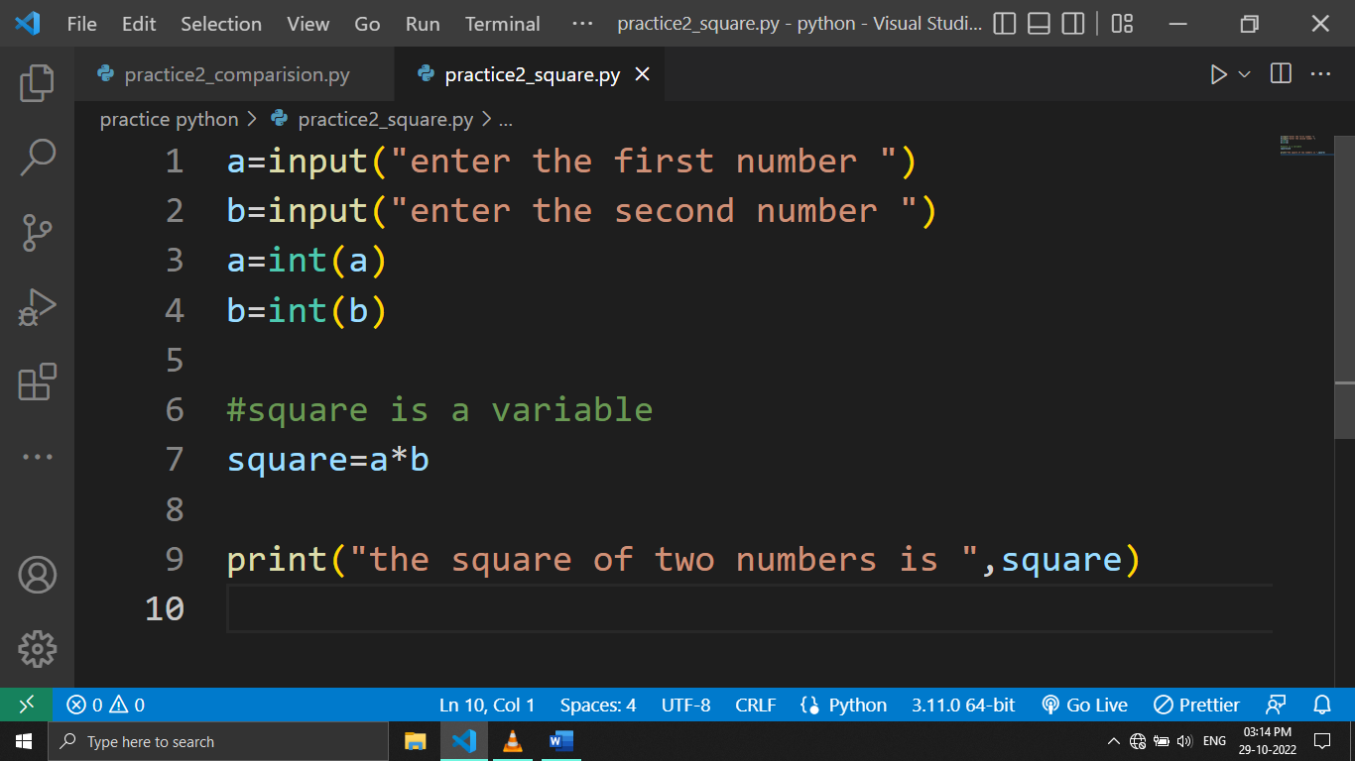

***OUTPUT:***

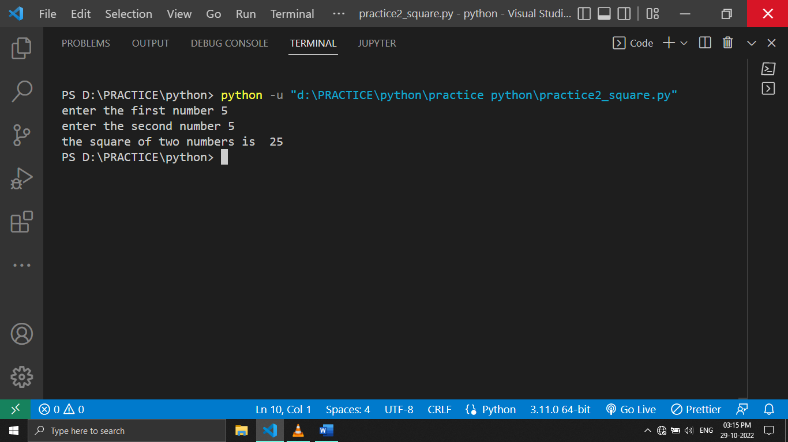

***Q6) WRITE A PYTHON PROGRAM TO DISPLAY USER ENTER NAME AND SHOULD WISH GOOD AFTERNOON USING INPUT FUNCTION***

***INPUT:***

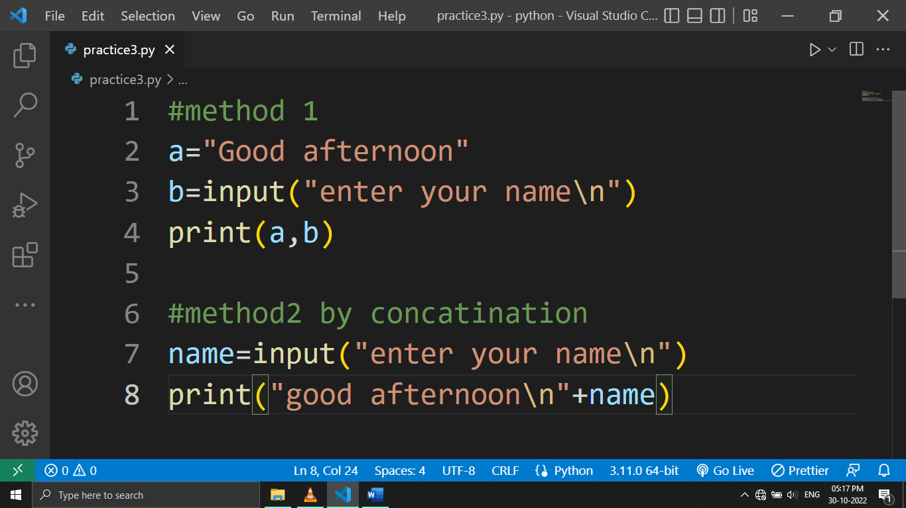

***OUTPUT:***

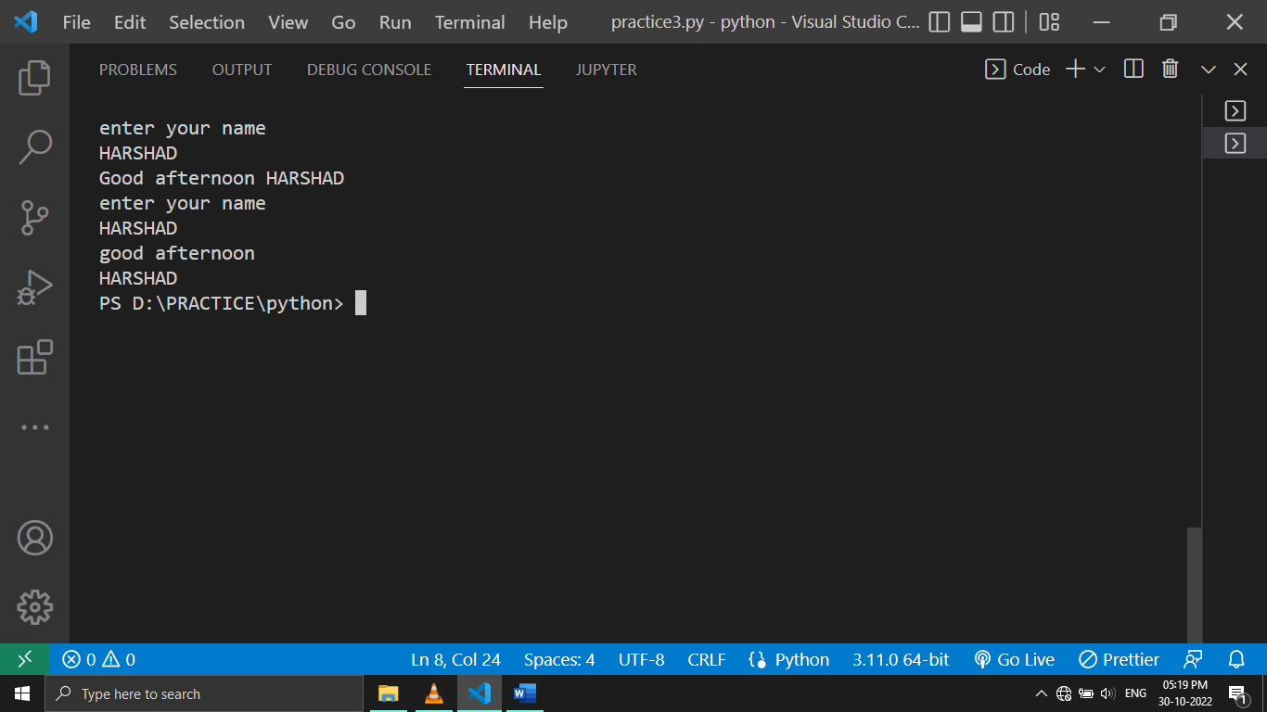

***Q7 )WRITE A PROGRAM TO FILL THE BELOW WITH NAME AND DATE***

'''Dear <|name|>\n

You are selected !\n

<|date|>'

***INPUT:***

letter='''Dear <|name|>\n

You are selected !\n

<|date|>'''

a=input("Enter the name ")

b=input("Enter the date ")

#here not to use print

letter=letter.replace("name",a)

letter=letter.replace("date",b)

print(letter)

***OUTPUT:***

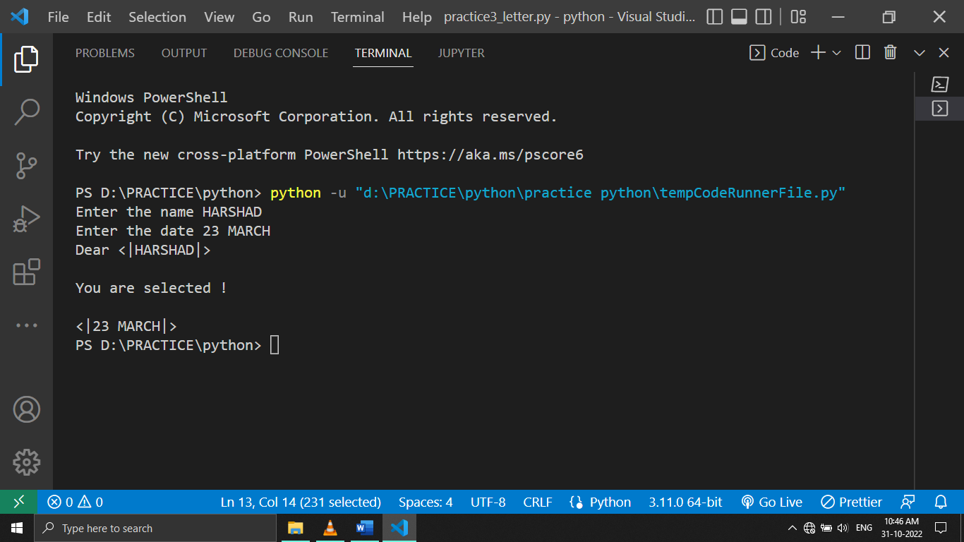

***Q8)PROGRAM TO STORE SEVEN FRUITS IN LIST BY USER INPUT***

***INPUT:***

#taking user input and storing it in a list

a1=input("Enter the 1st fruit name ")

a2=input("Enter the 2nd fruit name ")

a3=input("Enter the 3rd fruit name ")

a4=input("Enter the 4th fruit name ")

a5=input("Enter the 5th fruit name ")

a6=input("Enter the 6th fruit name ")

a7=input("Enter the 7th fruit name ")

a=[a1,a2,a3,a4,a5,a6,a7]

print("The list of all fruits is ", a )

***NOTE:(WRITE THE LIST AFTERWARDS ONLY NOT FIRST )***

***OUTPUT:***

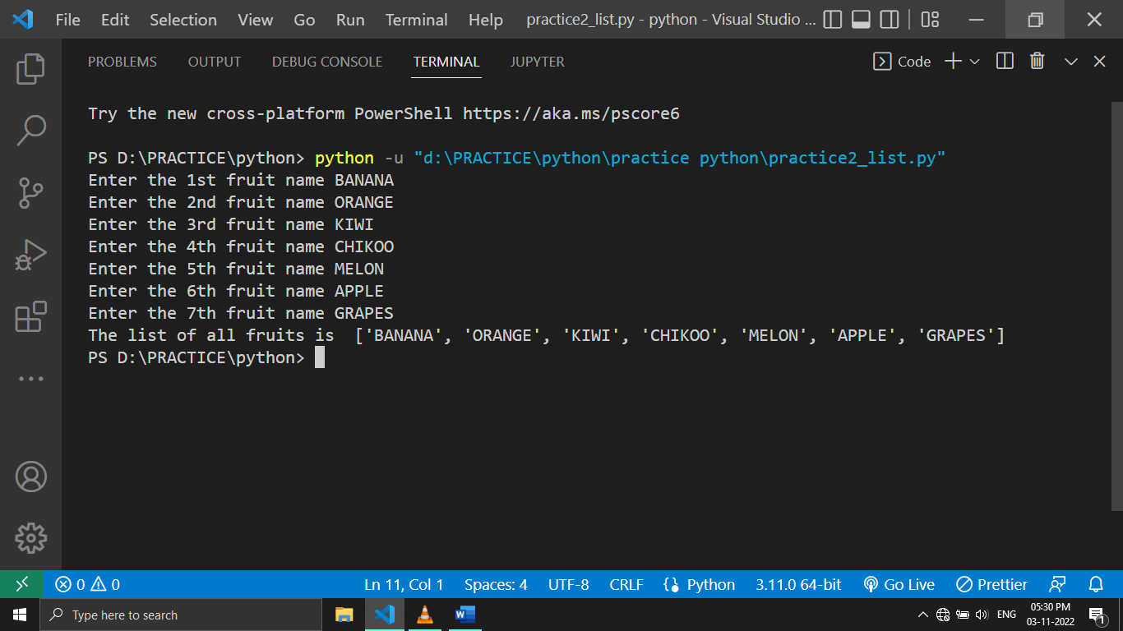

***Q9) PROGRAM TO TAKE INPUT OF 6 STUDENTS MARKS AND DISPLAY IT IN A SORTED MANNER***

***INPUT:***

#This is the another way to convert

stud1=int(input("ENTER MARKS OF STUDENT 1 :"))

stud2=int(input("ENTER MARKS OF STUDENT 2 :"))

stud3=int(input("ENTER MARKS OF STUDENT 3 :"))

stud4=int(input("ENTER MARKS OF STUDENT 4 :"))

stud5=int(input("ENTER MARKS OF STUDENT 5 :"))

stud6=int(input("ENTER MARKS OF STUDENT 6 :"))

main_list=[stud1,stud2,stud3,stud3,stud4,stud5,stud6]

#using sort method

main_list.sort()

print("ALL THE MARKS ENTER ARE :",main_list)

***OUTPUT:***

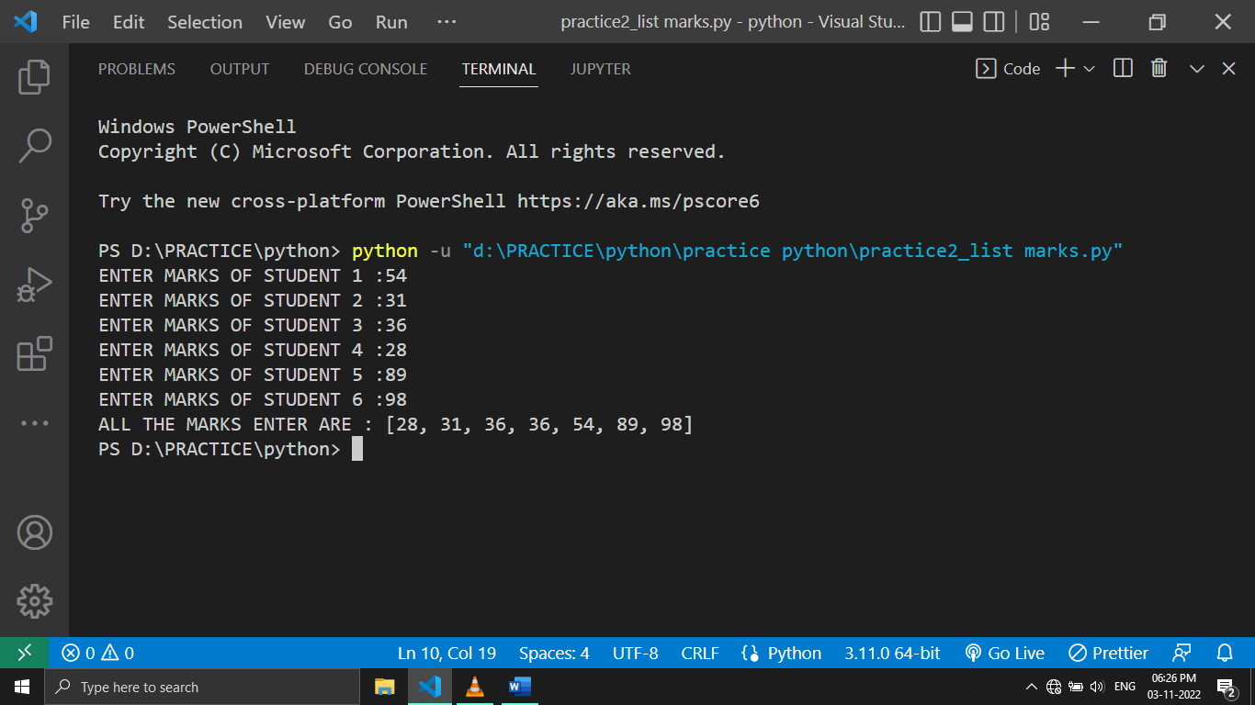

***Q10)SUM A LIST WITH 4 NUMBERS(this is not a best way )***

***INPUT:***

a=[25,15,12,14]

#method1

b= (a[0]+a[1]+a[2]+a[3])

print(b)

#method 2

a2=(1,2,3,4)

print(sum(a2))

***OUTPUT:***

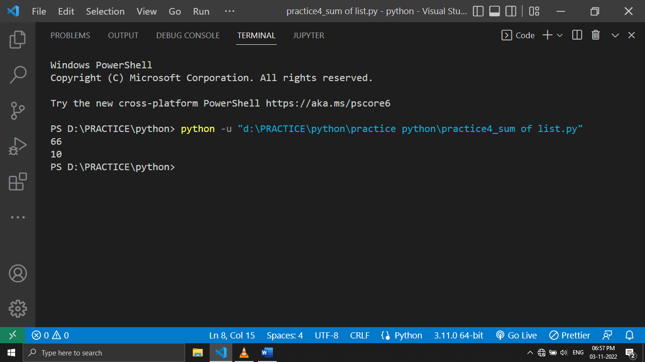

***Q11 )COUNT THE NUMBER OF ZEROS IN THE FOLLOWING TUPLE***

***A=(7,0,8,0,0,9)***

***INPUT:***

a=(7,0,8,0,0,9)

a=a.count(0)

print(a)

***OUTPUT:***

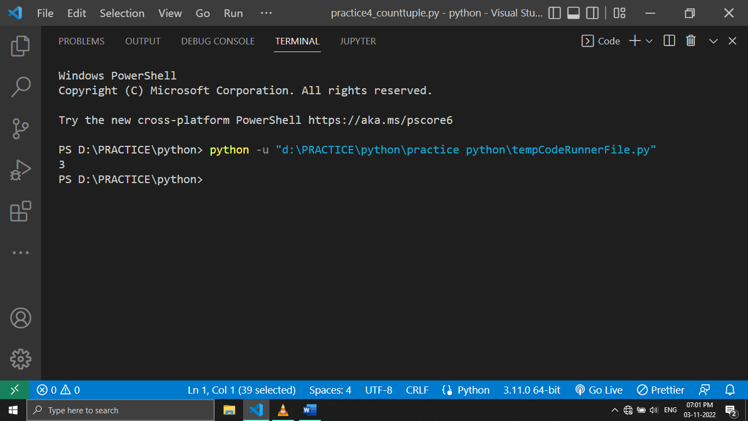

***Q12)CREATE A DICTIONARY AND WITH VALUES.PROVIDE USER WITH A OPTION TO LOOK IT UP***

***INPUT:***

dict={

    "APPLE":"IT IS A FRUIT ",

    "CAT":"IT IS A ANIMAL",

    "TIGER":"IT IS A CARNIVOROUS ANIMAL",

    "LION":"KING OF THE JUNGLE",

    "TORTOISE":"IT IS A REPLTILE "

}

print("OPTIONS  ARE",dict.keys()) #display keys

a=input("ENTER THE WORD FROM LIST :")

print("THE MEANING OF YOUR WORD IS:",dict.get(a))#this will take keys and display value

***OUTPUT:***

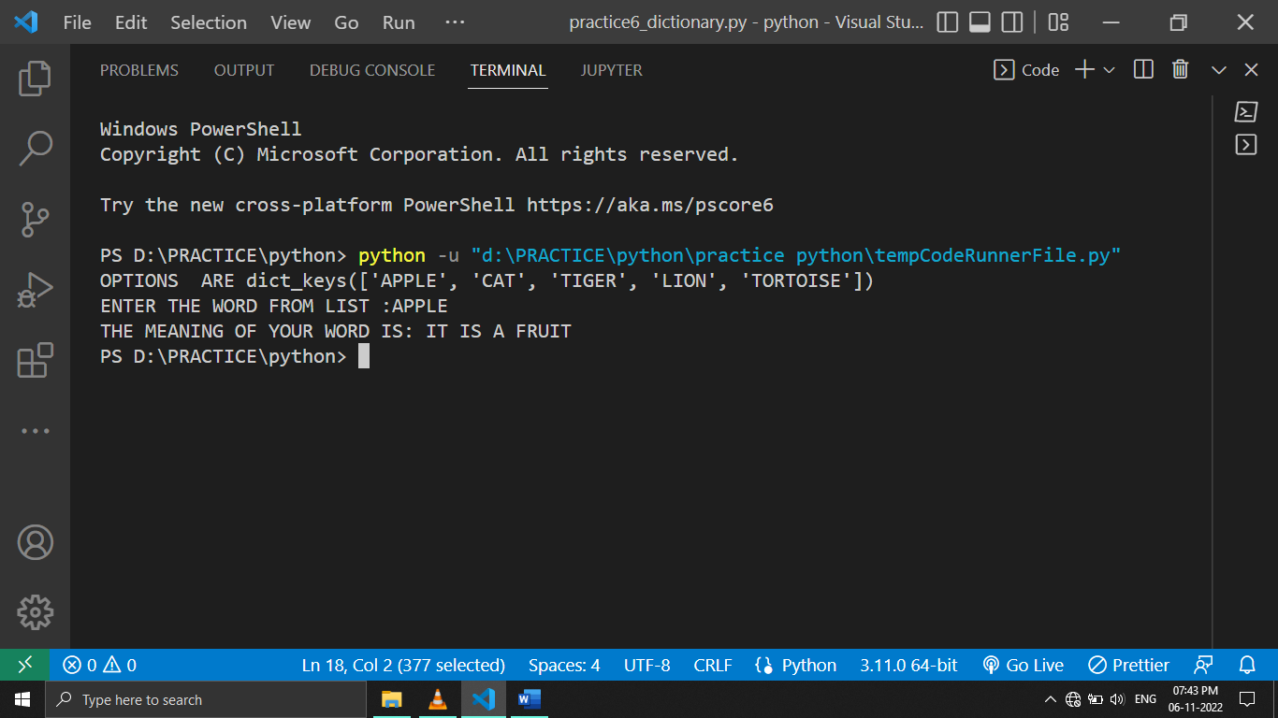

***Q13 )PROGRAM TO TAKE 8 NUMBERS FROM USER AND DISPLAY ALL THE UNIQUE NUMBERS***

***INPUT:***

b1=int(input("enter number 1 :"))

b2=int(input("enter number 2 :"))

b3=int(input("enter number 3 :"))

b4=int(input("enter number 4 :"))

b5=int(input("enter number 5 :"))

b6=int(input("enter number 6 :"))

b7=int(input("enter number 7 :"))

b8=int(input("enter number 8 :"))

a={b1,b2,b3,b4,b6,b7,b8}

print(a)

***OUTPUT:***

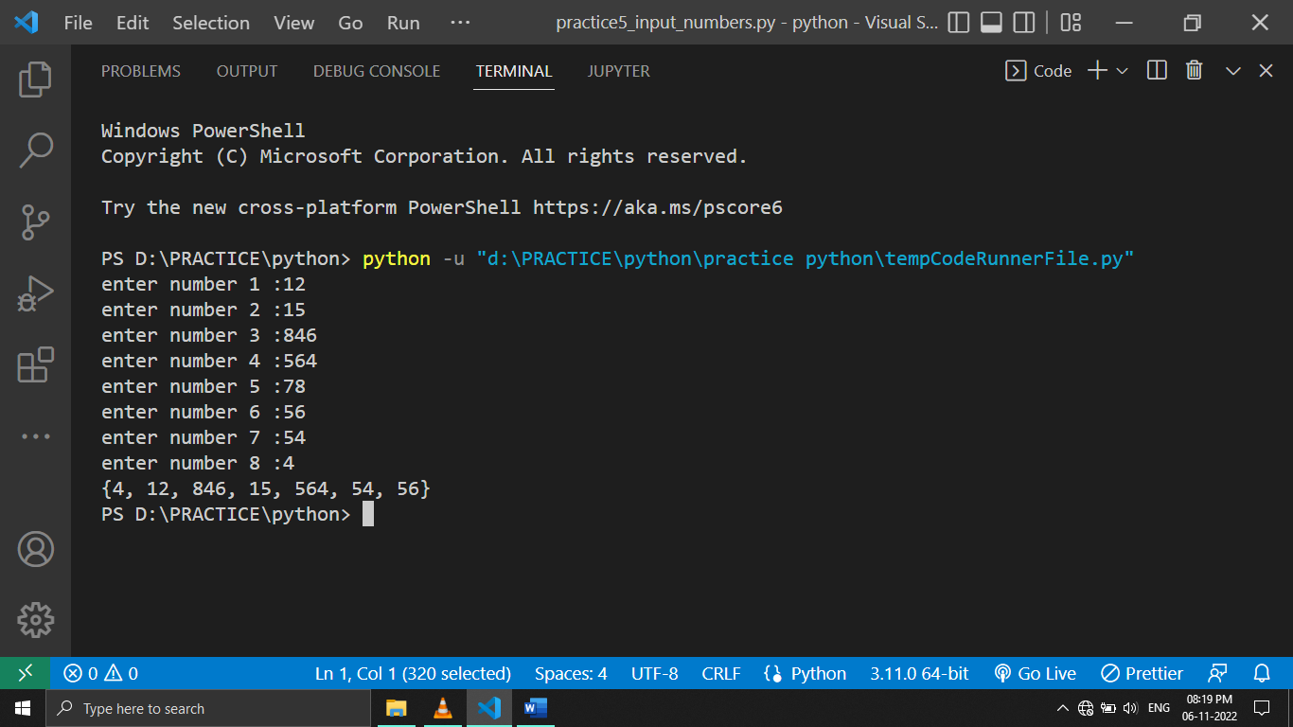

***Q14)LENGTH OF THE FOLLOWING SET S(UNIQUE)***

***INPUT:***

#UNIQUE CASE

#this will take the value one into consideration

s=set()

s.add(20)#same

s.add(20.0)#same

s.add("20")

print(len(s))

***OUTPUT:***

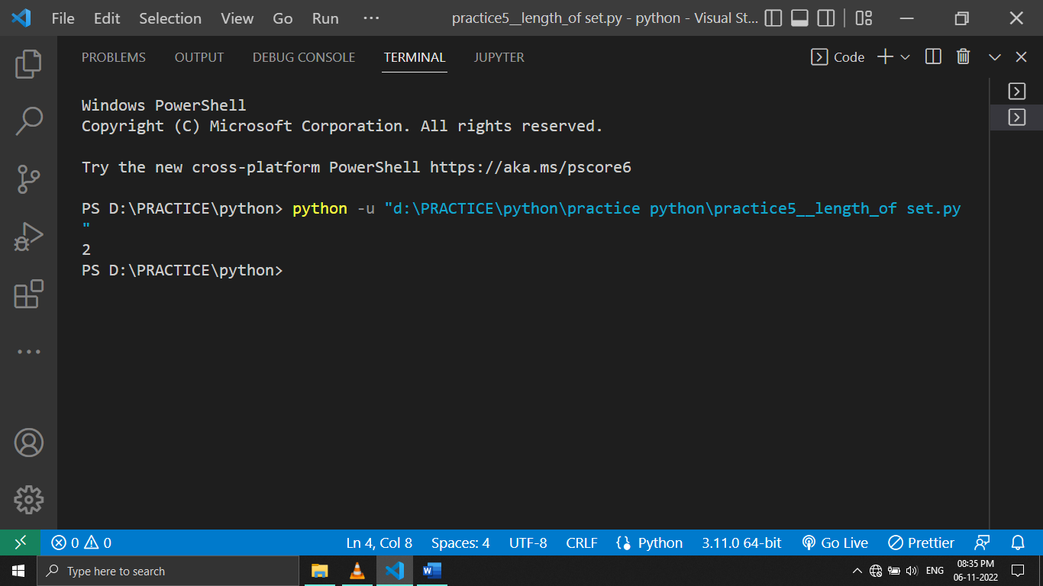

***Q15)CREATE A EMPTY DICTIONARY AND ADD VALUES BY USER INPUT ,MAKE FULL FLEDGE***

***INPUT:***

lang={}#empty dictionary

n1=input("ENTER YOUR FAVOURATE LANGUAGE MAU: ")

n2=input("ENTER YOUR FAVOURATE LANGUAGE COOKER: ")

n3=input("ENTER YOUR FAVOURATE LANGUAGE ANOYONIMOUS: ")

n4=input("ENTER YOUR FAVOURATE LANGUAGE V-RAO: ")

#keys are given by us

lang["mau"]=n1 #these are values

lang["cooker"]=n2

lang["anon"]=n3

lang["vrao"]=n4

print(lang)

***OUTPUT:***

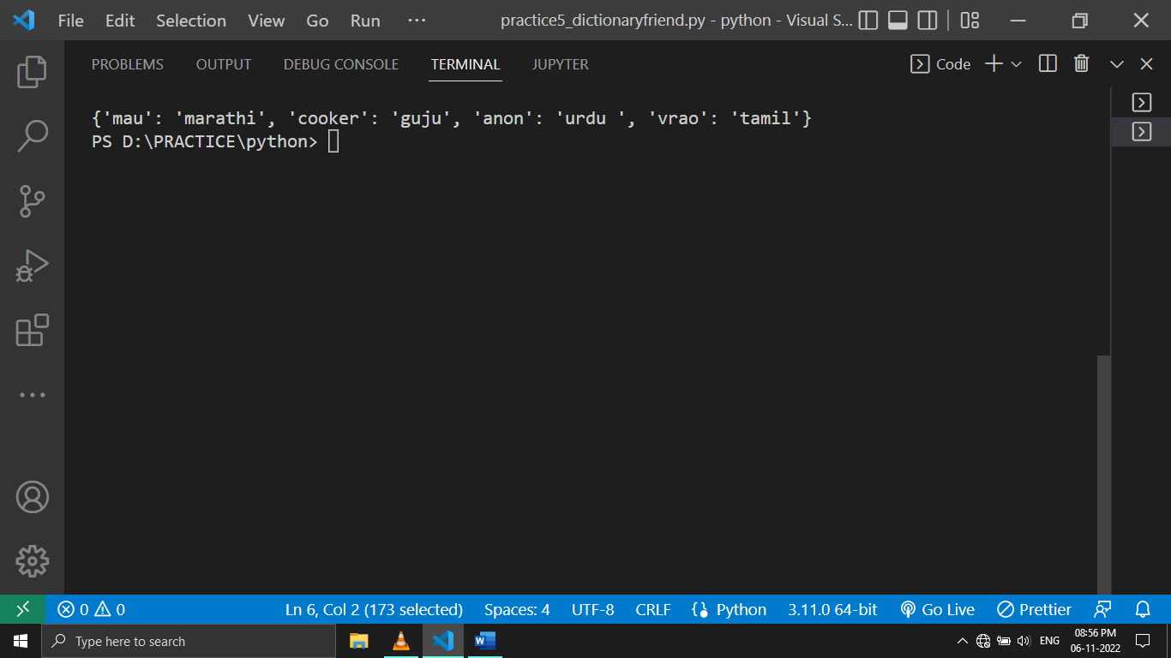

***Q16) PROGRAM TO FIND THE GREATEST OF FOUR NUMBER ENTER BY USER***

***(vvv impo)***

***INPUT:***

a1=int(input("ENTER NUMBER 1:"))

a2=int(input("ENTER NUMBER 2:"))

a3=int(input("ENTER NUMBER 3:"))

a4=int(input("ENTER NUMBER 4:"))

#1 and 4 chi match

if(a1>a4):

    new1=a1  #here new variable is created

else:

    new1=a4  #ithe mothi value store

#------------------------------------------------------------------

#2 and 3 chi match

if (a2>a3):

    new2=a2

else:

    new2=a3

#----------------------------------------------------

if(new1>new2):

    print(new1 ,"is greatest")

else:

    print(new2,"is greatest")

***OUTPUT:***

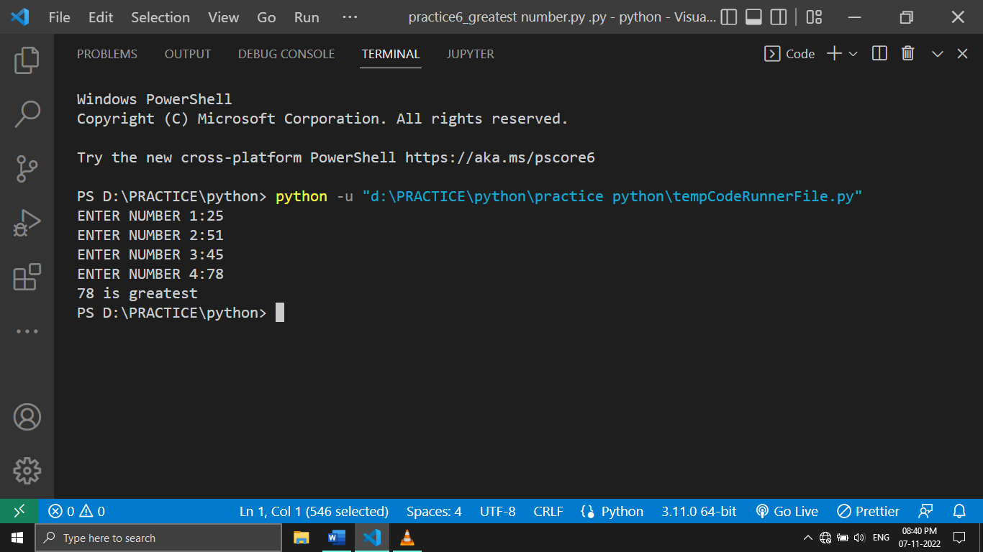

***Q17) WRITE A PROGRAM TO GET THE RESULT WEATHER THE STUDENT IS PASS OR FAIL BY TAKING 3 INPUTS***

***INPUT:***

sub1=int(input("enter marks of maths :"))

sub2=int(input("enter marks of science :"))

sub3=int(input("enter marks history :"))

if(sub1<35 or sub2<35 or sub3<35):

    print("YOU ARE FAIL BECAUSE YOU SCORE LESS THAN 35 MARKS ")

elif(sub1+sub2+sub3)/300 <35: #THIS CALCULATE PERCENTAGE

    print("your percentage is less than 35 so you failed")

else:

    print("congrat you are totally passed")

***OUTPUT:***

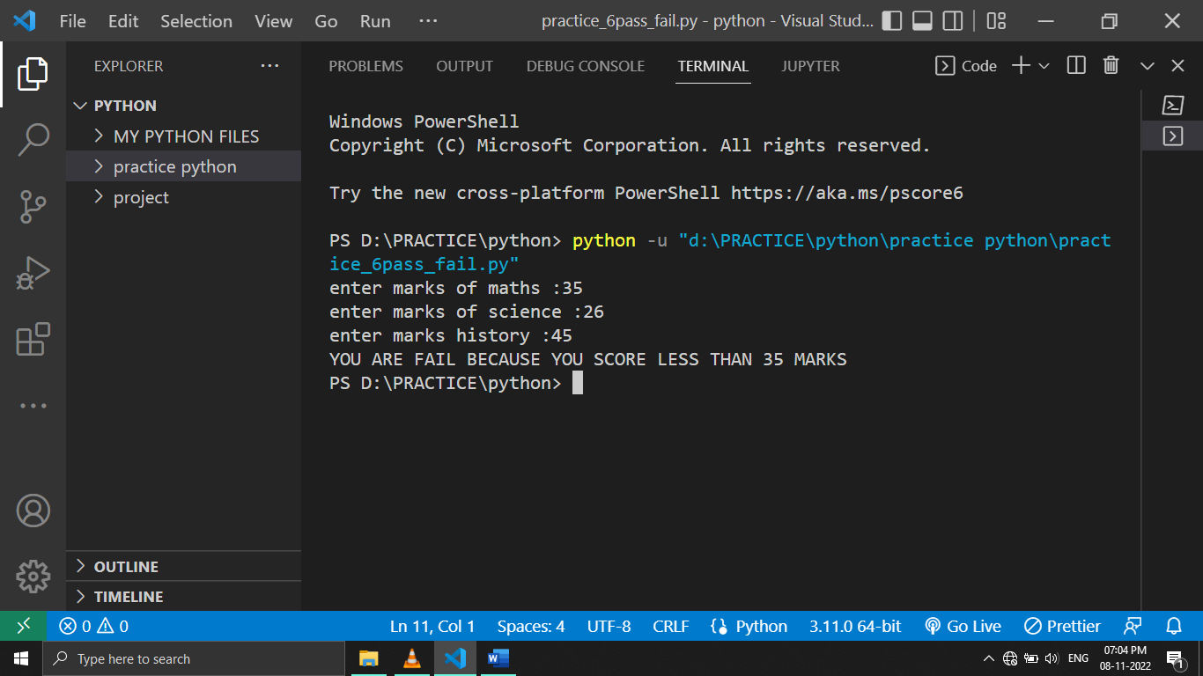

***Q18 )PROGRAM TO FIND OUT WEATHER THE GIVEN NAME IS PRESENT IN THE LIST***

***INPUT:***

name=["rahul","tina","riya","raj","harshad\n"]

nameenter=input("Enter your name to check\n")

if (nameenter in name):  #in check the values

    print("You are in the list\n")

else:

    print("not there")

***OUTPUT:***

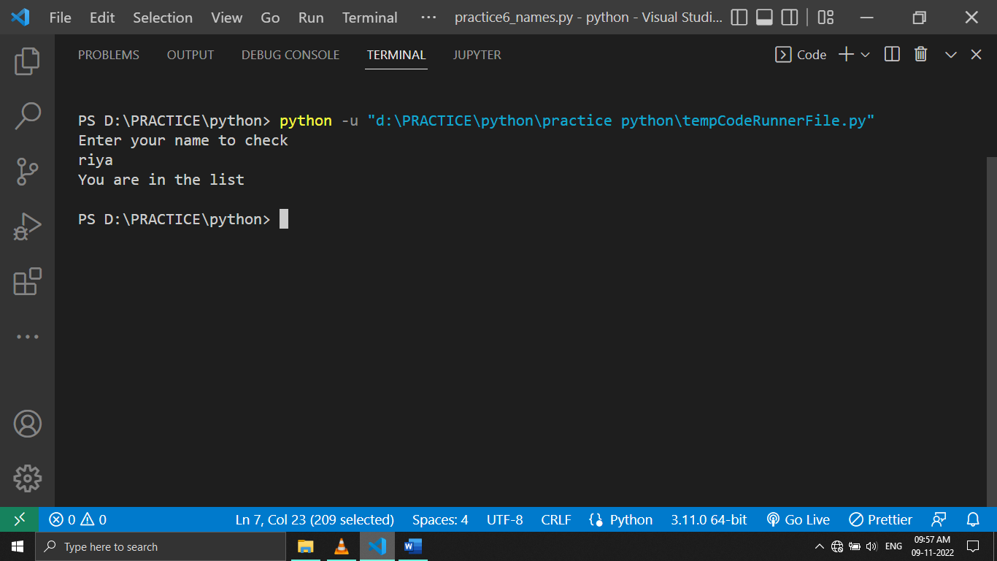

***Q19)PROGRAM TO CALCULATE GRADE OF THE STUDENTS USING IF ELSE***

***INPUT:***

grade=int(input("ENTER YOUR MARKS:\n"))

if(grade >90):

    print("EXECELLENT")

elif(grade>80):

    print("YOU GOT A GRADE")

elif(grade>70):

    print("YOU GOT B GRADE")

elif(grade>60):

    print("YOU GOT C GRADE")

elif(grade>50):

    print("YOU GOT D GRADE")

else:

    print("SORRY YOU ARE FAIL")

***OUTPUT:***

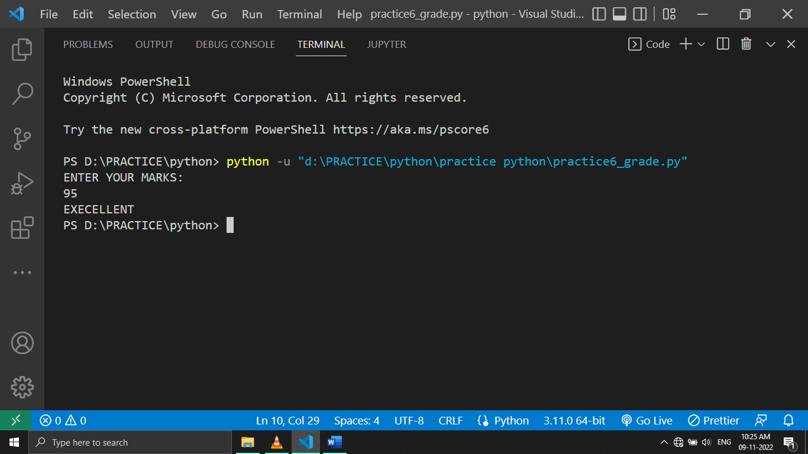

***Q20) MULTIPLICATION TABLE USING FOR LOOP (use this)***

***INPUT:***

num=(int(input("ENTER NUMBER\n")))

#here 1,2,3,4,5......11 will be load in a

for a in range(1,11):

#basic arithmetic operation between user input and loop (a)

    print(str(a),"=",a*num)

***OUTPUT:***

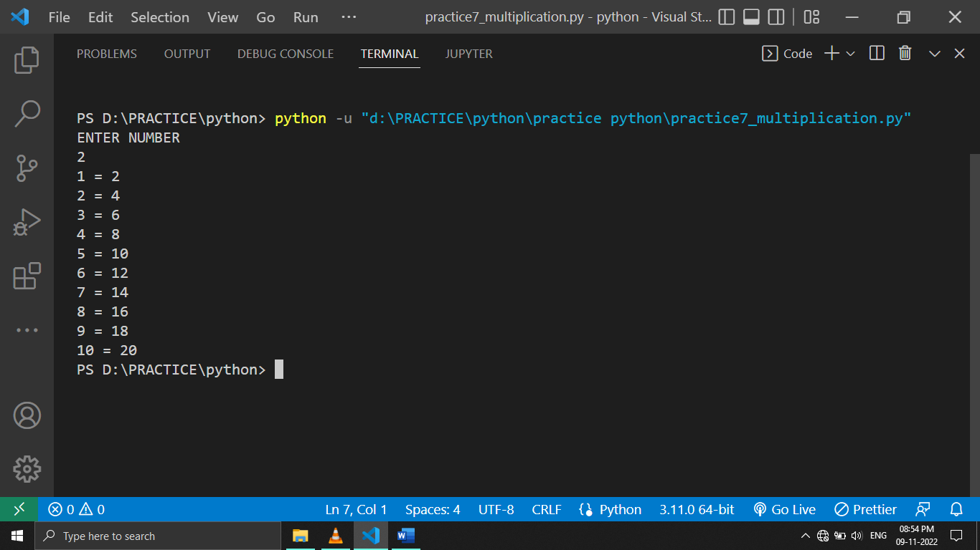

***Q21)PROGRAM TO GREET ALL PERSON IN LIST NAME STARTING WITH “S” USING FOR LOOP***

list=["harshad","sachin","sahil","shanti","nayana"]

***INPUT:***

list=["harshad","sachin","sahil","shanti","nayana"]

for name in list:

    if (name.startswith("s")):

        print("happy diwali",name)

    else:

        print("end")

***OUTPUT:***

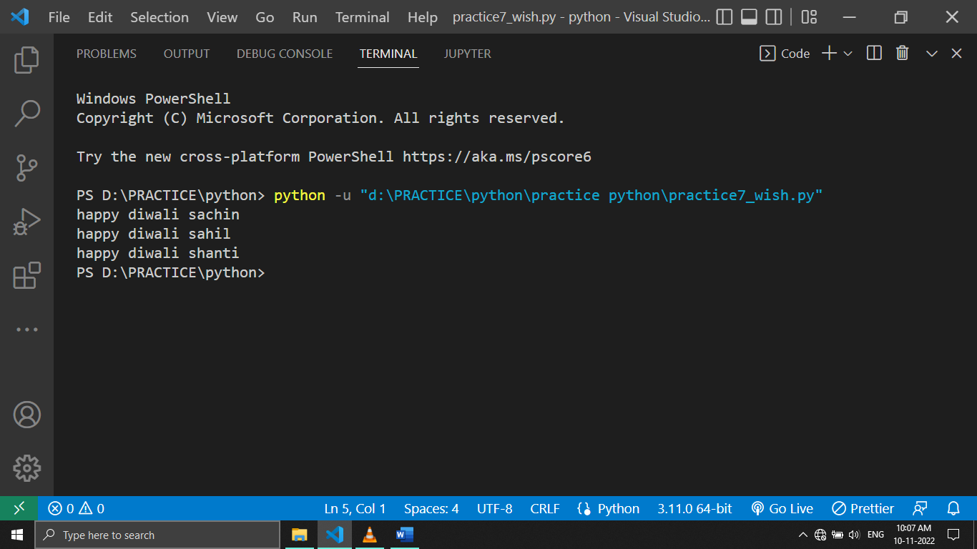

***Q22) MULTIPLICATION TABLE USING FOR WHILE LOOP***

***INPUT:***

num=int(input("ENTER NUMBER:\n"))

a=1

while (a<=10):

    print(a,"=",num*a)#a will be 123456......10

    a=a+1

***OUTPUT:***

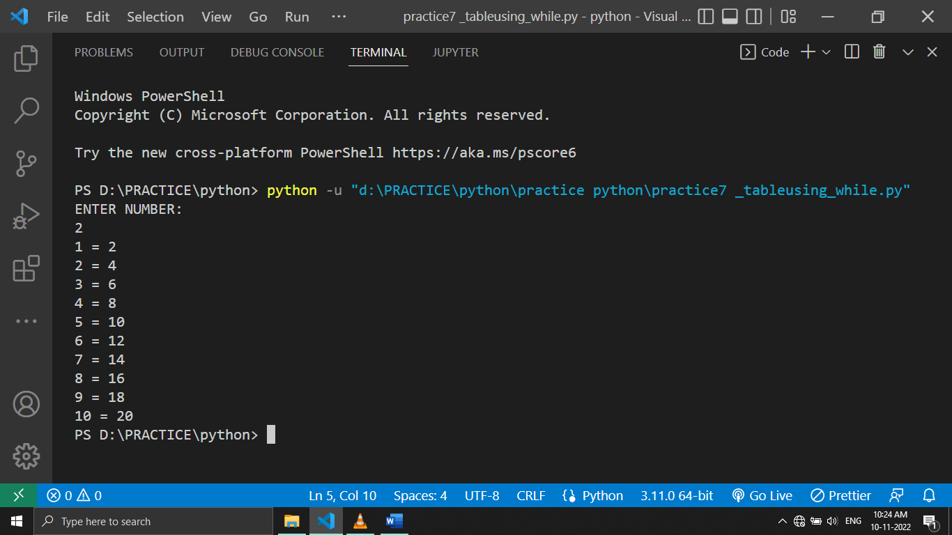

***Q23)PROGRAM TO WRITE WHEATHER NUMBER IS PRIME OR NOT***

***NOTE:PRIME NUMBER IS NUMBER WHICH IS DIVISIBLE 2 AND BY ITSELF***

***INPUT:***

num=int(input("ENTER NUMBER\n"))

#here we are assuming that it a prime number thats why true

prime=True

for a in range(2,num):  #<--- 2 bcoz ithun start

#jar kontaa pn number hyala divide marlaa trr number prime nasnrr

    if (num%a == 0):

        prime=False

        break

#-----------------

if prime:

    print("prime number")

else:

    print("not prime")

***OUTPUT:***

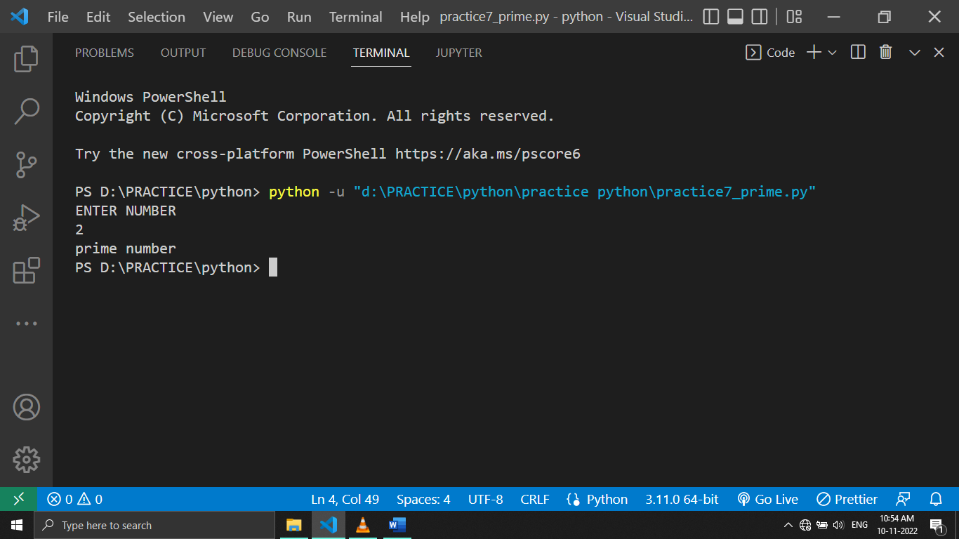

***Q24)SUM OF N NATURAL NUMBER USING WHILE LOOP***

***INPUT:***

***Wrrr code***

***OUTPUT:***

***Q25)FACTORAIL OF A NUMBER USING FOR LOOP***

***INPUT:***

num=int(input("enter number:\n"))

a=1  #<< to add extra number

#b madhe 123456.......

for b in range(1,num+1):

    a=a*b

print("the factoral of given number ",b, "is:" ,a)

***OUTPUT:***

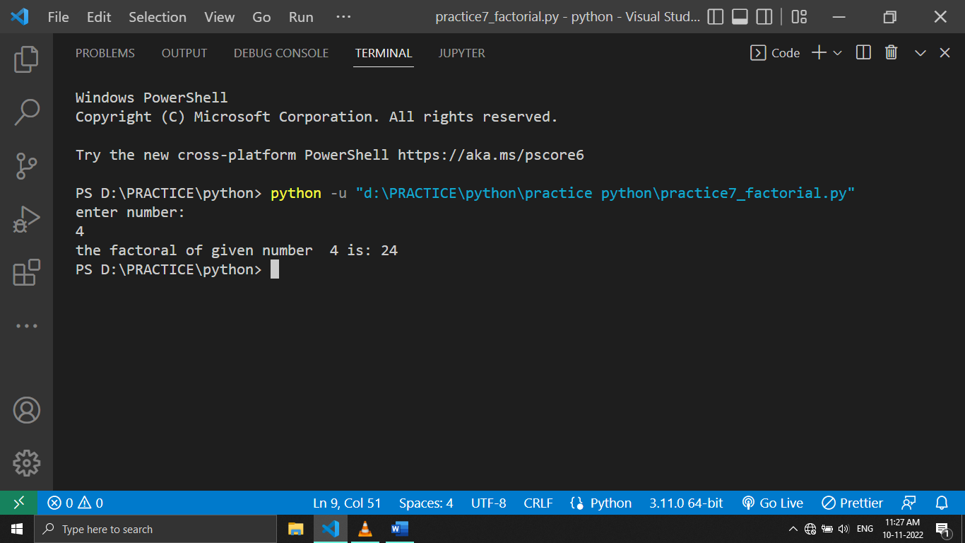

***Q26)PROGRAM TO PRINT PATTERN N=3***

***\****

***\*\*\****

***\*\*\*\*\****

***INPUT:***

n=3

for i in range(3):

    print(" " *(n-i-1),end="")#this end will remove newline space

    print("*" *(2*i+1),end="")

    print(" " *(n-i-1))

***OUTPUT:***

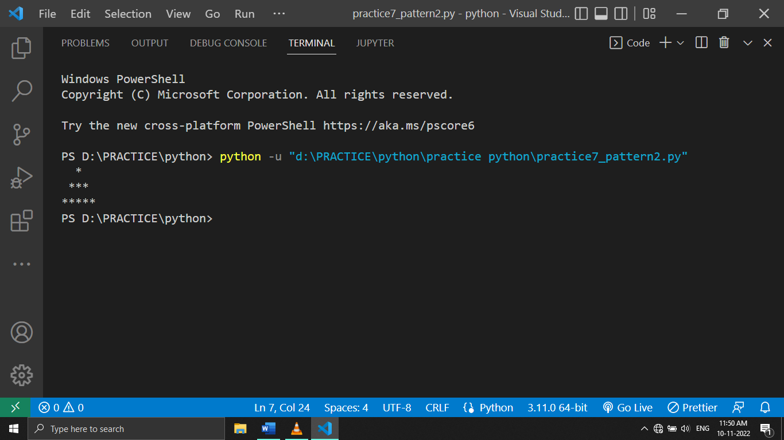

***Q27) PROGRAM TO PRINT PATTERN N=3***

***\****

***\*\****

***\*\*\****

***INPUT:***

#here i will be loaded with 123...4

for i in range(4):

    print("*" *  i)

***OUTPUT:***

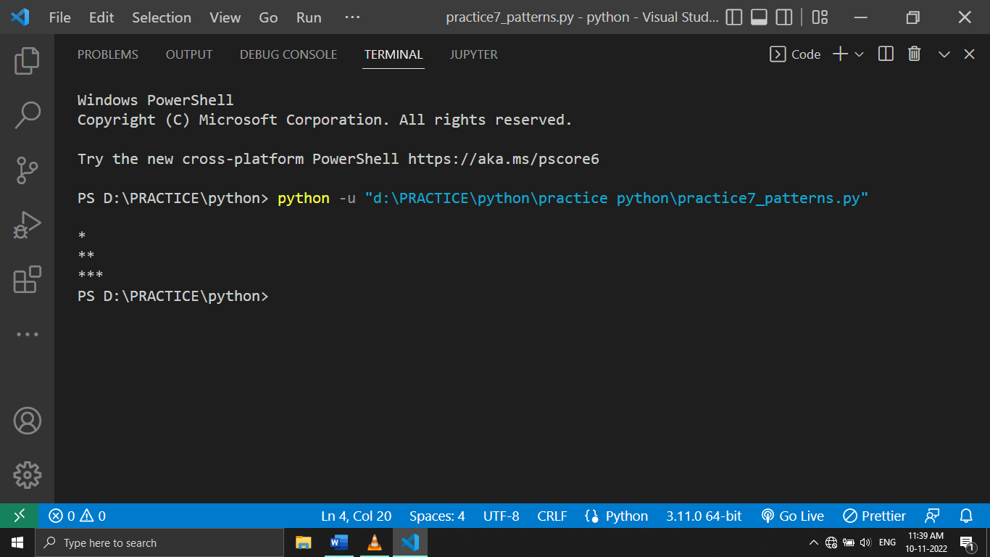

***Q28)***

***INPUT:***

***OUTPUT:***

***Q29)***

***INPUT:***

***OUTPUT:***

***Q30)***

***INPUT:***

***OUTPUT:***

***Q31)***

***INPUT:***

***OUTPUT***

***Q32)***

***INPUT:***

***OUTPUT***

***Q33)***

***INPUT:***

***OUTPUT***

***Q34)***

***INPUT:***

***OUTPUT***

***Q35)***

***INPUT:***

***OUTPUT***

***Q36)***

***INPUT:***

***OUTPUT***

***Q37)***

***INPUT:***

***OUTPUT***

***Q38)***

***INPUT:***

***OUTPUT***

***Q39)***

***INPUT:***

***OUTPUT***

***Q40)***

***INPUT:***

***OUTPUT***